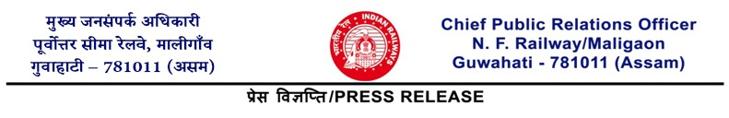
No. 416 BULLETIN -1

TRAIN DERAILED DUE TO DASHING WITH ELEPHANT
NO CASUALTY OR INJURY TO PASSENGERS

Maligaon : 20th December, 2025: At about 02-17 hrs on the morning of 20-12-2025, an unfortunate incident took place in the Jamunamukh - Kampur section under Lumding Division of N.F. Railway, where Train no. 20507 DN Sairang - New Delhi Rajdhani Express dashed with elephants, resulting in derailment of the locomotive and five coaches of the train. However, there are no casualties or injuries to any passenger. The area is about 126 km away from Guwahati. Accident Relief trains along with officials from the divisional HQ is already at site. Helpline numbers have already been activated at Guwahati railway station, which are 0361-2731621 / 2731622 / 2731623.
Senior railway officers including the General Manager of N.F. Railway and Divisional Railway Manager of Lumding have also rushed to the site. The passengers of the affected coaches have been temporarily accommodated in the vacant berths available in other coaches. The derailment effected train after detaching the affected coaches has left the site for Guwahati at 06-11 hrs. Once the train reaches Guwahati, additional coaches will be added to accommodate the passengers of the affected coaches, and the train will resume its journey.
The incident took place at a location which is not a designated elephant corridor. The loco pilot on observing the herd of elephants applied emergency brakes. However elephants dashed with the train.
Trains scheduled to pass through that section are being diverted through the UP line. Restoration works are on.

(Kapinjal Kishore Sharma)
Chief Public Relations Officer

For latest news and updates, please follow us on Twitter @RailNf and in Facebook @NFRailway

